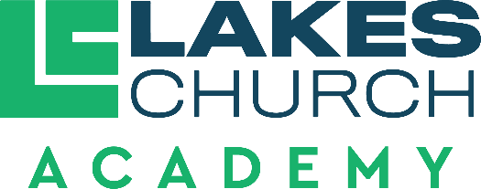

Job Title | Elementary Teacher
Reports to | Assistant Principal of Administration

Job purpose
- An Elementary Teacher seeks to fulfil the mission of Lakes Church Academy by developing a Christ-centered environment where students receive a solid education from a biblical worldview.

Duties and responsibilities
- Model Christian character and behavior at all times.
- Be able to effectively share the Gospel when appropriate with students and their families.
- For students who are Christians. Be able to identify a child’s spiritual maturity level and help them grow in their faith.
- Work to promote peace and unity within the school body with Administrators, Pastors, fellow teachers, volunteers, parents and students.
- Exhibit self-motivation, self-direction, leadership in and out of the classroom.
- Teach curriculum adopted by the Academy, that aligns with the Florida B.E.S.T. standards. Teachers may use supplemental materials to enhance learning that align with our beliefs in the Baptist Faith and Message.
- Develop activities that are in accord with the standards, curriculum and emphasize integration of a Biblical worldview.
- Be able to differentiate within grade level to meet varying needs.
- Maintain an organized, engaging classroom environment using consistent, kind and structured discipline.
  - Maintain orderliness and discipline in all activities.
  - Be responsible for the safety of each student during school hours.
  - Work closely with parents, provide time for parent conferences and complete conference forms.
  - Attend and participate in staff meetings, in-service trainings, and other meetings or other meetings or conferences classed by an Administrator.
  - Maintain accurate and current student progress, discipline and attendance records. Input accurate grades weekly into our online platform.
  - Evaluate each student’s progress with tools provided by the Administrators.
  - Maintain up-to-date lesson plans, making easily available for an Administrator to see.
  - Provide adequate plans and information for a substitute teacher in event of teacher absence.
  - Maintain proper teacher certification.
  - Demonstrate a continuing effort to improve as a teacher.
  - Work cooperatively with fellow staff members.
  - Work to meet standards of excellence.

- Perform other duties as assigned by the Head of School (Senior Pastor), Executive Pastor, Associate Pastor, the Assistant Principal of Administration and Assistant Principal of Spiritual Development.

Qualifications
- A clear Christian testimony, a demonstrable mature Christian faith and a commitment to a biblical worldview.
- Supports and follows the leadership and vision of Lakes Church and Lakes Church Academy.
- Actively attending Lakes Church or a church of like faith.
- Affirm and comply with the Baptist Faith and Message (2000).
- Affirm agreement with the Employment Agreement and Faculty Handbook of Lakes Church Academy.
- Affirm agreement with the Statement of Cooperation for Lakes Church employees.
- Complete all background and employment screening of Lakes Church.
- Bachelor’s Degree in Education.
- State of Florida Teaching Certificate
- Minimum of two years professional experience in classroom instruction.
- Ability to integrate lessons with a Biblical worldview across the curriculum.
- Confidential and trustworthy.
- Positive and hardworking.
- Professional, well-mannered, disciplined, and responsible.

Direct reports
An Elementary Teacher works under the supervision of the Assistant Principal of Administration and the Assistant Principal to Spiritual Development. An Elementary Teacher is accountable to the Senior Pastor (Head of School), the Executive Pastor, the Associate Pastor and the Personnel Committee of Lakes church.
Approved by:
Date approved:
Reviewed:

