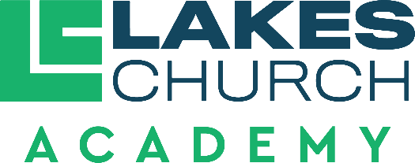

Job Title | Paraeducator
Reports to | Assistant Principal of Administration

Job purpose
- A Paraeducator seeks to fulfil the mission of Lakes Church Academy by developing a Christ-centered environment where students receive a solid education from a biblical worldview.

Duties and responsibilities
- Model Christian character and behavior at all times.
- Be able to effectively share the Gospel when appropriate with students and their families.
- For students who are Christians. Be able to identify a child’s spiritual maturity level and help them grow in their faith.
- Work to promote peace and unity within the school body with Administrators, Pastors, fellow teachers, volunteers, parents and students.
- Exhibit self-motivation, self-direction, leadership in and out of the classroom.
- Assist the classroom teacher with curriculum adopted by the Academy, that aligns with the Florida B.E.S.T. standards.
- Assist the classroom teacher with activities that are in accord with the standards, curriculum and emphasize integration of a Biblical worldview.
- Assist the classroom teacher in maintaining an organized, engaging classroom environment using consistent, kind and structured discipline.
  - Assist in maintaining orderliness and discipline in all activities.
  - Assist with the safety of each student during school hours.
  - Attend and participate in staff meetings, in-service trainings, and other meetings or other meetings or conferences classed by an Administrator.
  - Assist in maintaining accurate and current student progress, discipline and attendance records. Input accurate grades weekly into our online platform.
  - Assist in evaluating each student’s progress with tools provided by the Administrators.
  - Assist in maintaining up-to-date lesson plans.
  - Demonstrate a continuing effort to improve as a paraeducator.
  - Work cooperatively with fellow staff members.
  - Work to meet standards of excellence.

- Perform other duties as assigned by the Head of School (Senior Pastor), Executive Pastor, Associate Pastor, the Assistant Principal of Administration and the Classroom teacher.

Qualifications
- A clear Christian testimony, a demonstrable mature Christian faith and a commitment to a biblical worldview.
- Supports and follows the leadership and vision of Lakes Church and Lakes Church Academy.
- Actively attending Lakes Church or a church of like faith.
- Affirm and comply with the Baptist Faith and Message (2000).
- Affirm agreement with the Employment Agreement and Faculty Handbook of Lakes Church Academy.
- Affirm agreement with the Statement of Cooperation for Lakes Church employees.
- Complete all background and employment screening of Lakes Church.
- Minimum of two years professional experience in classroom instruction.
- Confidential and trustworthy.
- Positive and hardworking.
- Professional, well-mannered, disciplined, and responsible.

Direct reports
A Paraeducator works under the supervision of the Classroom Teacher and the Assistant Principal of Administration. A Paraeducator is accountable to the Senior Pastor (Head of School), the Executive Pastor, the Associate Pastor and the Personnel Committee of Lakes church.
Approved by:
Date approved:
Reviewed:

