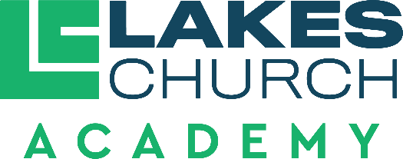

Job Title | Preschool Teacher
Reports to | Assistant Principal of Administration

Job purpose
- A Preschool Teacher seeks to fulfil the mission of Lakes Church Academy by developing a Christ-centered environment where students receive a solid education from a biblical worldview.

Duties and responsibilities
- Model Christian character and behavior at all times.
- Be able to effectively share the Gospel when appropriate with students and their families.
- Be able to explain biblical principles essential to helping children learn and understand the Bible.
- Work to promote peace and unity within the school body with Administrators, Pastors, fellow teachers, volunteers, parents and students.
- Exhibit self-motivation, self-direction, leadership in and out of the classroom.
- Teach curriculum adopted by the Academy. Teachers may use supplemental materials to enhance learning that align with our beliefs in the Baptist Faith and Message.
- Develop activities that are in accord with the standards, curriculum and emphasize integration of a Biblical worldview.
- Be able to differentiate within age level to meet varying needs.
- Maintain an organized, engaging classroom environment using consistent, kind and structured discipline.
  - Maintain orderliness and discipline in all activities.
  - Be responsible for the safety of each student during school hours.
  - Work closely with parents, provide time for parent conferences and complete conference forms.
  - Attend and participate in staff meetings, in-service trainings, and other meetings or other meetings or conferences classed by an Administrator.
  - Maintain accurate and current student progress, discipline and attendance records.
  - Evaluate each student’s progress with tools provided by the Administrators.
  - Maintain up-to-date lesson plans, making easily available for an Administrator to see.
  - Provide adequate plans and information for a substitute teacher in event of teacher absence.
  - Maintain proper teaching certifications.
  - Demonstrate a continuing effort to improve as a teacher.
  - Work cooperatively with fellow staff members.
  - Work to meet standards of excellence.

- Perform other duties as assigned by the Head of School (Senior Pastor), Executive Pastor, Associate Pastor, the Assistant Principal of Administration and Assistant Principal of Spiritual Development.

Qualifications
- A clear Christian testimony, a demonstrable mature Christian faith and a commitment to a biblical worldview.
- Supports and follows the leadership and vision of Lakes Church and Lakes Church Academy.
- Actively attending Lakes Church or a church of like faith.
- Affirm and comply with the Baptist Faith and Message (2000).
- Affirm agreement with the Employment Agreement and Faculty Handbook of Lakes Church Academy.
- Affirm agreement with the Statement of Cooperation for Lakes Church employees.
- Complete all background and employment screening of Lakes Church.
- A minimum of an Associate’s Degree.
- Early Child Education training.
- Minimum of two years professional experience in Early Childhood Education.
- Confidential and trustworthy.
- Positive and hardworking.
- Professional, well-mannered, disciplined, and responsible.

Direct reports
An Preschool Teacher works under the supervision of the Assistant Principal of Administration and the Assistant Principal to Spiritual Development. A Preschool Teacher is accountable to the Senior Pastor (Head of School), the Executive Pastor, the Associate Pastor and the Personnel Committee of Lakes church.
Approved by:
Date approved:
Reviewed:

