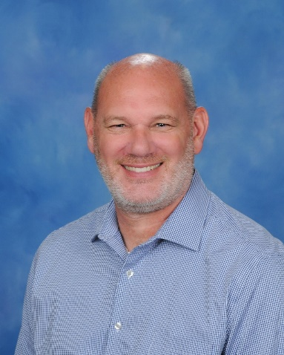Dr. Keith Overholt

# Education

## Doctor of education | 2017 | Southeastern University - Lakeland, FL

* Major: Organizational Leadership

## master of science | 2006 | clarks summit university - Clarks summit, PA

* Major: Christian School Education/ Educational Leadership

## bachelor of science | 1993 | clarks summit university - Clarks summit, pa

* Major: Bible/Elementary Education

# Experience

## Associate head of school/High school principal | Seffner christian school 2023-25

## Associate head of school for academics/Secondary principal | 2020-2023

## Secondary Principal | lakeland christian school | 2016-2020

## middle school principal | lakeland christian school | 2006-2016

## lakeland christian school Admin and classroom teacher| 1993-2006

## Extra-curricular

* Coached basketball for 22 years.
* Student Leadership University coordinator.

# Family

# Married to my wife, Jennifer, for 31 years.

# Seven children, a son-in-law and one grandchild.

# LCA Opportunity

# "I am humbled and excited to join the LCA team to continue a lifelong calling to further Kingdom Education. I am thrilled with the opportunity to lay a foundation at LCA that will continue *Building Champions for Chris*t for generations to come."